Backing Up and Restoring System Files Lab

Ryan Coon

CYB-515

Dr. Edward Marchewka

October 9, 2024

Part 1:

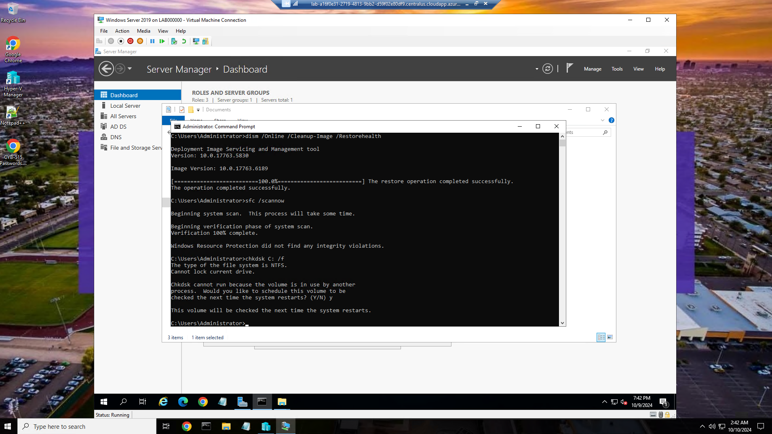

Here I ran the DISM image cleanup, scannow, and the chkdsk on drive C. Will now reset in order to run the chkdsk.

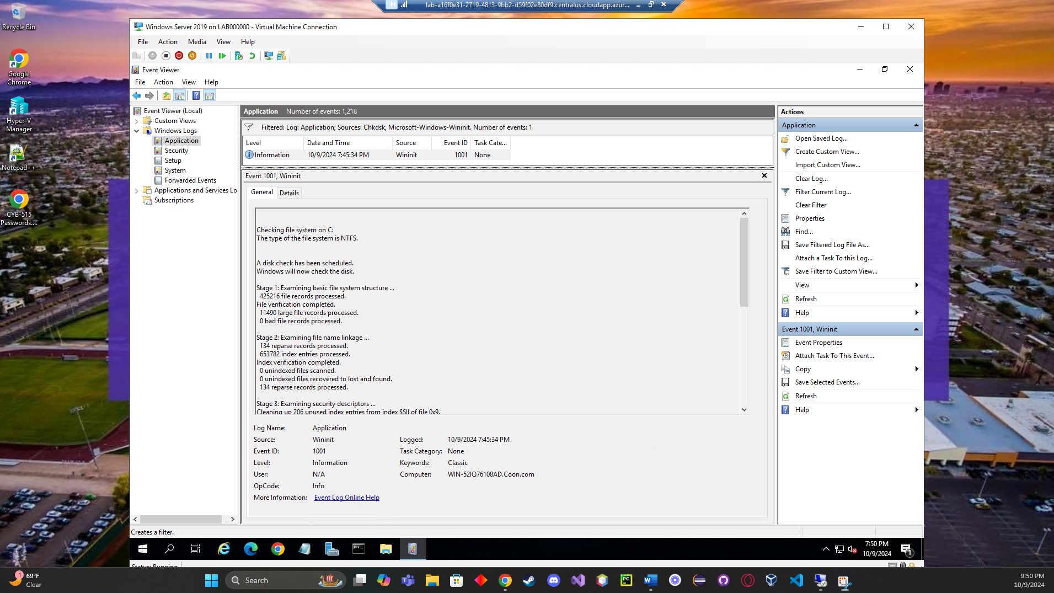

Successful completion of chkdsk through Administrator tools and event viewer.



We can also run a script in Powershell and get the same result.

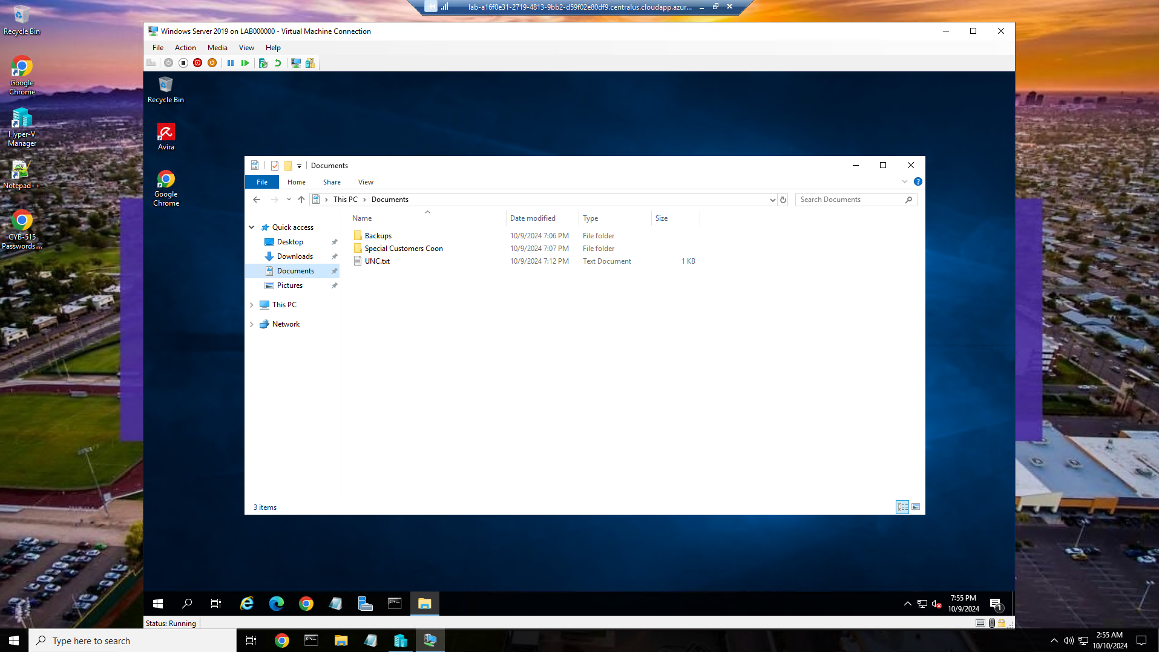

Special customers folder created within the documents folder.

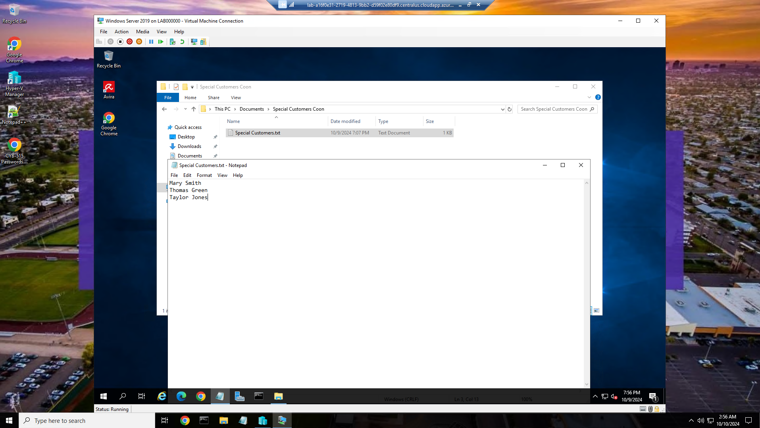

Special Customers text file with 3 customers created within the Special Customers folder.

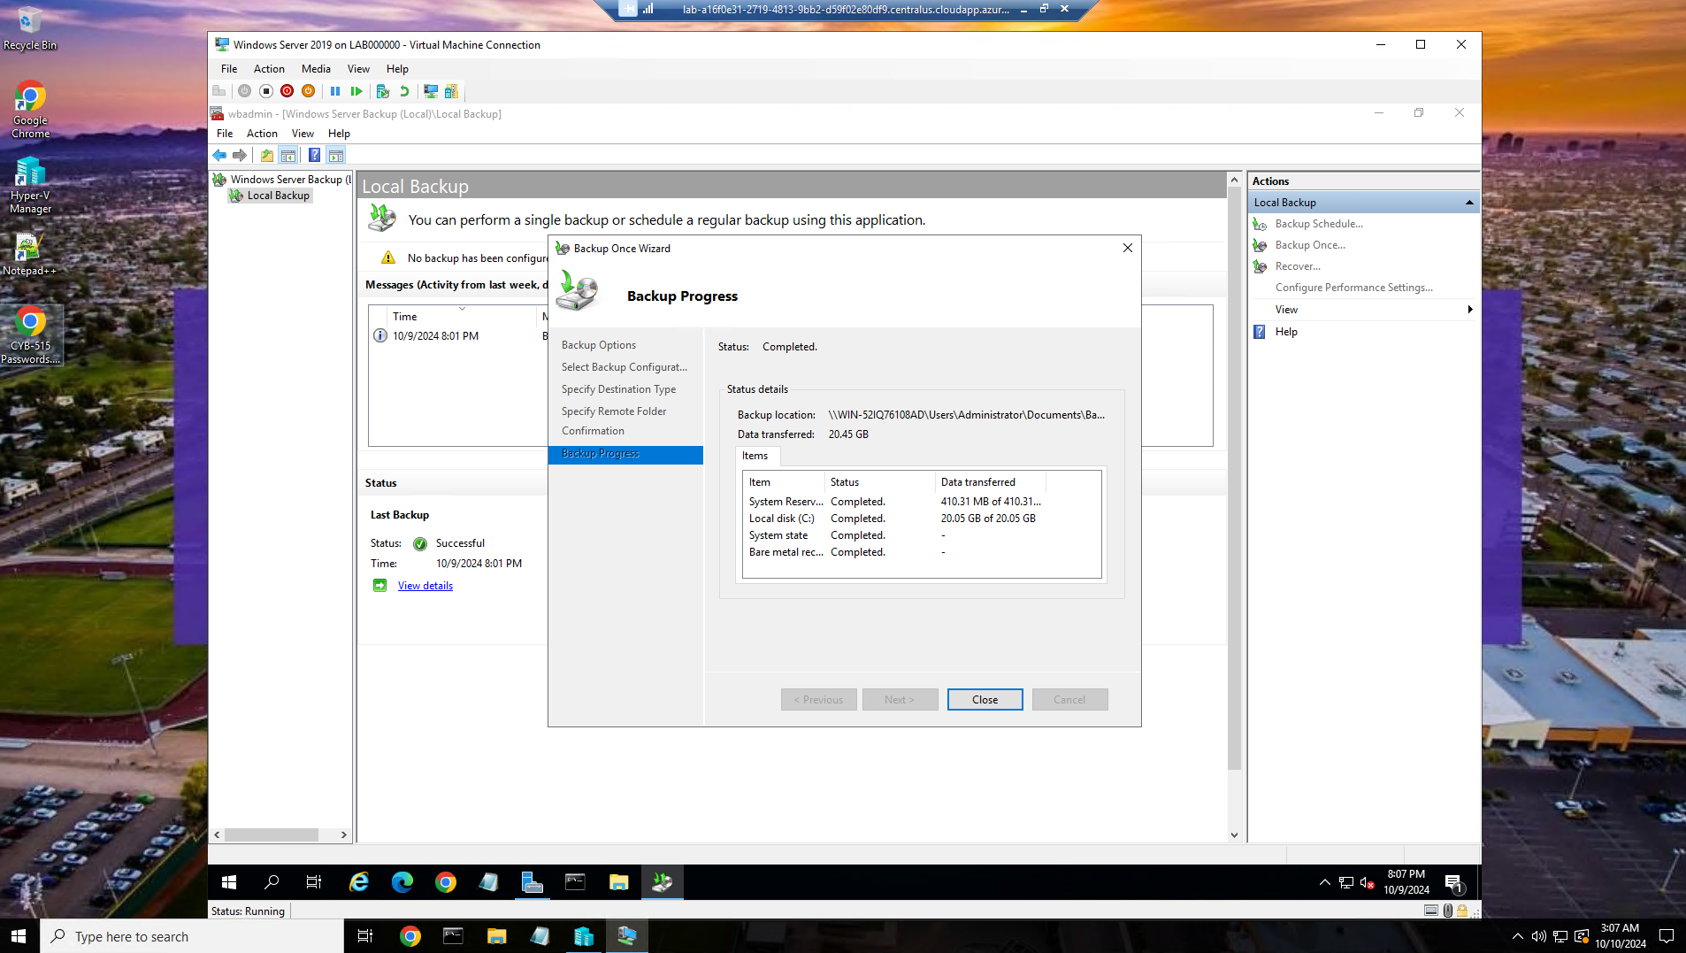

Successfully performed a full backup of the entire server.

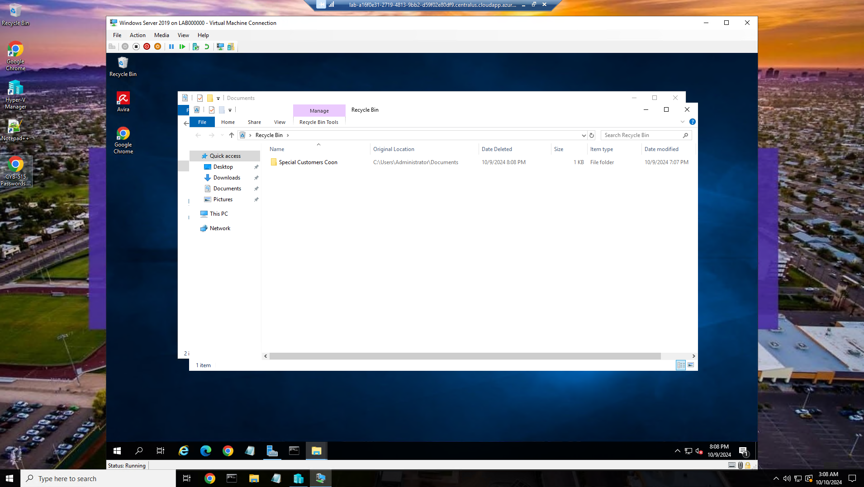

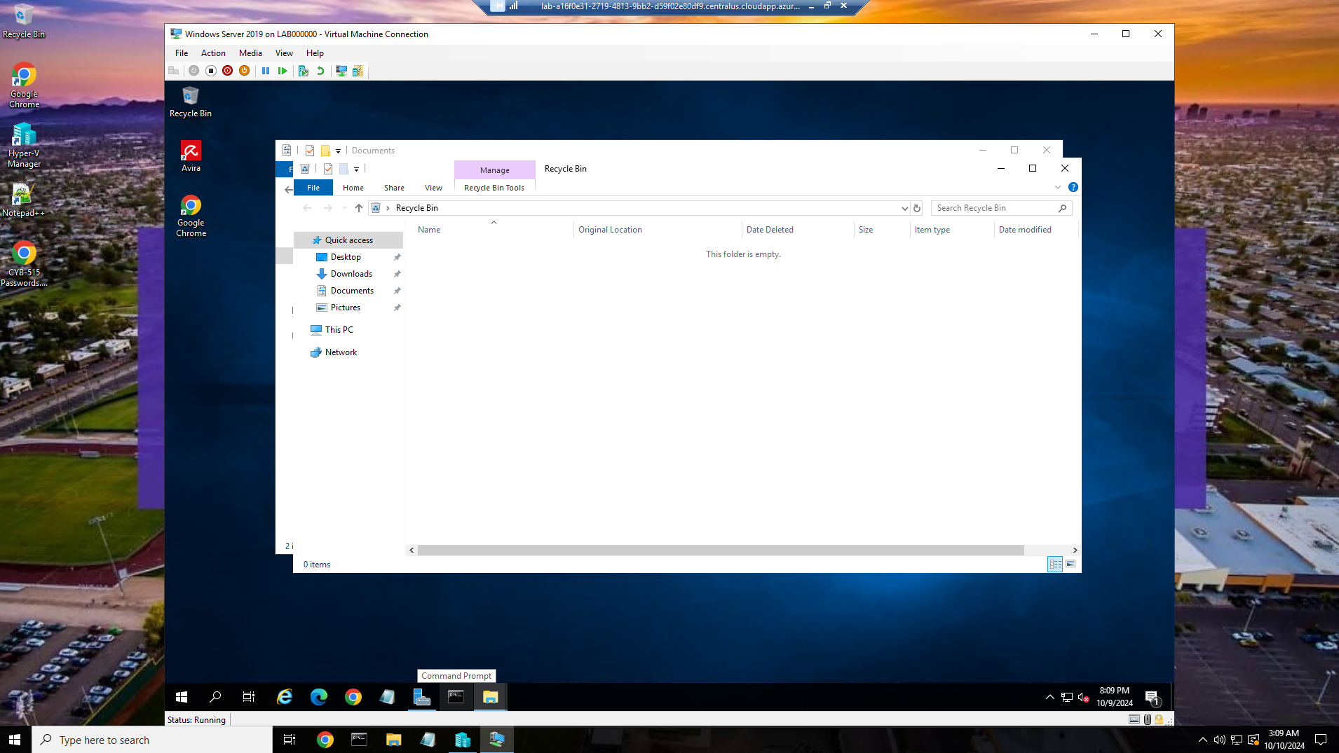

Deleted the Special Customers folder and ensured that the recycle bin was emptied.

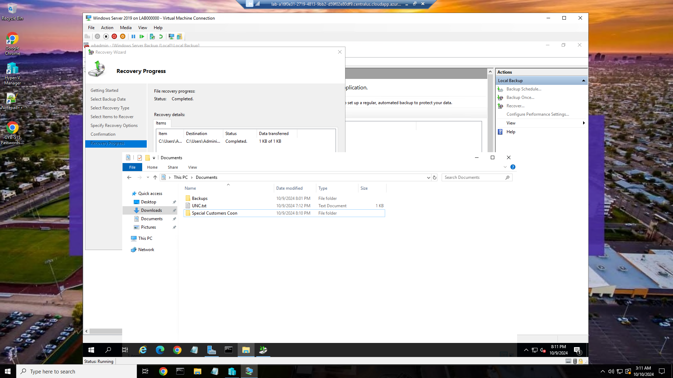

Backup Recovery completed and Special Customers folder is back in our documents folder.

Part 2:

**Describe how you perform backups and restore data to the system from a backup.**

For backups, you could use a multitude of techniques. You could use incremental backups to capture only changes since the last full backup, saving time and storage space. You could also employ differential backups, which capture all changes since the last full backup, offering a faster restore process. In this exercise I ran a sort of differential backup, to only restore files that were chosen by me.

For data restoration, I use the backup software's restore functionality. I can choose to restore the entire system, specific files or folders, or even individual files. The process involves selecting the backup image and specifying the target location for the restored data.

**Provide a summary of what you were accomplishing when you completed the backup and tested whether it was functioning correctly.**

I just finished creating a comprehensive backup of my system's critical data. This backup includes all essential files, configurations, and system settings, ensuring a complete snapshot of your current state. To verify the backup's integrity, I performed a test restore of a file that was chosen by me. This confirmed that the backup process was successful and the data can be reliably restored if needed.

**Explain why performing backups and having the ability to restore files is an essential skill for cybersecurity professionals.**

Backups and restoration are crucial for cybersecurity professionals because they provide a safety net against data loss caused by malicious attacks or system failures(Writer, 2024). By having a reliable backup, professionals can quickly recover critical data and systems after a breach, minimizing downtime and potential financial losses(The Importance of Data Backups, 2023). This ability to restore data helps ensure business continuity and protects sensitive information from falling into the wrong hands.

References:

*Data Backup: Its Importance for Cybersecurity*. (2023, March 20). Morgan Stanley. https://www.morganstanley.com/articles/data-backup-importance-cybersecurity

USGS. (n.d.). *Backup & Secure | U.S. Geological Survey*. Www.usgs.gov. https://www.usgs.gov/data-management/backup-secure

Writer, A. (2024, May 16). *How Data Backups Bolster Cybersecurity*. Athreon: A Leader among Speech-To-Text Transcription and Cybersecurity Companies. https://www.athreon.com/how-data-backups-bolster-cybersecurity/